Book
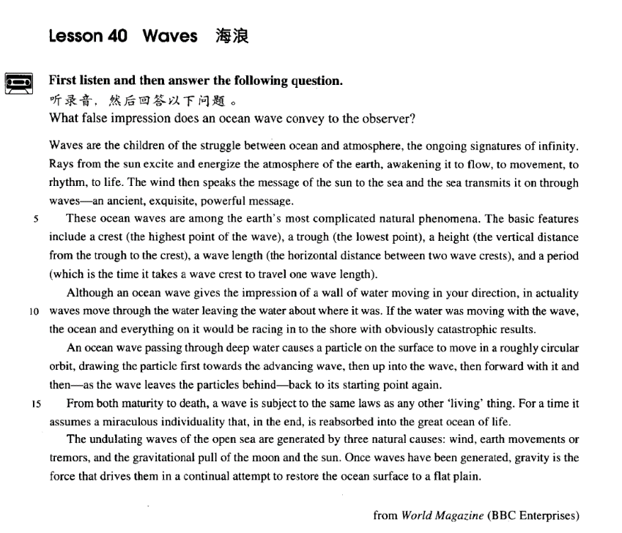

课文
Waves are the children of the struggle between ocean and atmosphere, the ongoing signatures of infinity.
海浪是大海和空气相斗的产物，无限的一种不间断的标志。

Rays from the sun excite and energize the atmosphere of the earth, awakening it to flow, to movement, to rhythm, to life.
太阳光刺激了地球的大气层，并给予它能量；阳光使空气开始流动，产生节奏，获得生命。

The wind then speaks the message of the sun to the sea and the sea transmits it on through waves -- an ancient, exquisite powerful message.
然后，风把太阳的住处带给了大海，海洋用波浪的形式传递这个信息 -- 一个源过流长、高雅而有力的信息。

These ocean waves are among the earth's most complicated natural phenomena.
这些海浪属于地球上最复杂的自然现象。

The basic features include a crest (the highest point of the wave), a trough (the lowest point), a height (the vertical distance from the trough to the crest), a wave length (the horizontal distance between two wave crests), and a period (which is the time it takes a wave crest to travel one wave length).
它们的基本特征包括浪峰（波浪的最高点）、波谷（最低点）、浪高（从波谷到浪峰的垂直距离）、波长（两个浪峰间的水平距离）和周期（海峰走过一个波长所需的时间）。

Although an ocean wave gives the impression of a wall of water moving in your direction, in actuality waves move through the water leaving the water about where it was.
虽然，海浪给人的印象是一堵由水组成的墙向你压过来，而实际上，浪从水中移过，而水则留在原处。

If the water was moving with the wave, the ocean and everything on it would be racing in to the shore with obviously catastrophic results.
如果水和浪一起移动的话，那么大海和海里所有的东西就会向岸边疾涌过来，带来明显的灾难性后果。

An ocean wave passing through deep water causes a particle on the surface to move in a roughly circular orbit, drawing the particle first towards the advancing wave, then up into the wave, then forward with it and then -- as the wave leaves the particles behind -- back to its starting point again.
穿过深水的海浪使水面上的一个微粒按照一种近乎圆形的轨道移动，先把微粒拉向前移动的海浪，然后推上波浪，随着波浪移动，然后 -- 当波浪把微粒留在身后时 -- 又回到出发点。

From both maturity to death, a wave is subject to the same laws as any other 'living' thing.
从成熟到消亡，波浪和其他任何“活动中”的东西一样，都受制于共同的法则。

For a time it assumes a miraculous individuality that, in the end, is reabsorbed into the great ocean of life.
一度它获得非凡的个性，但最终又被重新融进生命的大洋。

The undulating waves of the open sea are generated by three natural causes: wind, earth movements or tremors, and the gravitational pull of the moon and the sun.
公海上起伏的波浪是由3个自然因素构成的：风、地球的运动或震颤和月亮、太阳的引力。

Once waves have been generated, gravity is the force that drives them in a continual attempt to restore the ocean surface to a flat plain.
一旦波浪形成，地球引力是持续不断企图使海面复原为平面的力量。

词汇讲解

infinity
- infinity [ɪn'fɪnəti] n. 无限的时间或空间，无穷远
infinity n. [U] 英文解释：a space, time, or distance that continues without end or limits 无限的时间或空间，无穷远
- the infinity of space
- a barren landscape stretching into infinity

【词根】
“fin” = to end
finale n. 终曲，结局
finalize v. 使完成，使结束
finite adj. 有限的

“in” = not
infinite adj. 无限的
infinity n. 无限的时间或空间，无穷远
infinitive n.（动词）原形，不定式

“con” = together
confine v. 限制；拘禁
confinement n. 限制；拘禁

“de” = down
define v. 下定义
definition n. 定义
definite adj. 明确的
indefinite adj. 不明确的
definitive adj. 最终的；最好的；确定无疑的

“re” = again
refine v. 提炼；改良
refined adj. 精炼的；文雅的
refinement n. 精炼；文雅

transmit
- transmit [træns'mɪt] v. 传输；传播
transmit v. 含义1. to send an electronic signal, radio or television broadcast, etc. 传输（信号，节目等）
- The ceremony was transmitted live by satellite to over fifty countries.

transmit v. 含义2. to pass sth. from one person to another 将某事物传送、传递、传达或传染给对方
- sexually transmitted diseases
- transmit knowledge from one generation to another
- The tension soon transmitted itself to all the members of the crowd.

【词根】
“mit” / “miss” = send
intermit “inter” = between v. 暂停
intermittent adj. 断续的；间歇的
intermission n. 暂停；幕间休息

“ad” = to
admit v. 准许进入；承认
admission n. 准许进入；承认

“e” = out
emit v. 发射，发出
emission n. 发射，发出

“o” / “ob” = away
omit v. 省略，删除；忽略，疏忽
omission n. 省略，删除；忽略，疏忽

“per” = through
permit v. 允许
permission n. 允许

“sub” = under
submit v. 提交，上交；服从，屈服
submission n. 提交，上交；服从，屈服
submissive adj. 服从的，顺从的

“trans” = across
transmit v. 传输，传染
transmission n. 传输，传染

“re” = back
remit v. 赦免，宽恕；汇款
remission n. 赦免，宽恕
remittance n. 汇款

“manu” = hand
manumit v. 解放（奴隶）
manumission n.（奴隶的）解放

exquisite
- exquisite [ɪk'skwɪzɪt] ['ɛkskwɪzɪt] adj. 精致的；高雅的
exquisite adj. 含义1. extremely beautiful and very delicately made 精致的
- exquisite craftsmanship
- Her wedding dress was absolutely exquisite.

exquisite adj. 含义2. very sensitive and delicate in the way you behave or do things 高雅的
- She has exquisite taste in art.

【词根】
“quire” / “quisit” / “quest” = to seek

“ex” = out
exquisite adj. 精致的；高雅的
“in” = into
inquire v. 询问，打听
inquest n.（对死因的）调查
inquisition n. 盘问；宗教法庭
inquisitive adj. 好奇的；爱打听的

“ac” = to
acquire v. 获得，取得
acquisition n. 获得；获得物
acquisitive adj. 贪婪的

“per” = thoroughly
perquisite n. 特权；额外收入

“re” = again
requisite n. 必需品；adj. 必须的

“pre” = before
prerequisite n. 先决条件，前提；adj. 必备的，作为先决条件的
requisition n. 征用；v. 征用

“dis” = apart
disquisition n. 专题论文；专题演讲

phenomena
- phenomena [fə'nɒmɪnə] n. 现象（复数）
phenomenon n. (pl phenomena) 英文解释：a fact or an event in nature or society, especially one that is not fully understood 现象
- natural / social / historical phenomena
- An eclipse of the moon is a rare phenomenon.
- Early retirement is a relatively new phenomenon in Britain.

【扩展】不规则单复数变化：
phenomenon → phenomena
criterion → criteria
medium → media
datum → data
stratum → strata
bacterium → bacteria
curriculum → curricula

catastrophic
- catastrophic [7kætə'strɒfɪk] adj. 灾难性的
catastrophic adj. 英文解释：causing a lot of damage or making a lot of people suffer
= disastrous 灾难性的
- catastrophic floods
- a catastrophic fall in the price of rice
- The failure of the talks could have catastrophic consequences.

【同根词】Lesson03-33
catastrophe n. 特大灾难
- The telephone rings and this marks the prelude to an unforeseen series of catastrophes.

【近义词】不同程度
mishap 小事故
accident （交通）事故；意外遭遇；不测事件
contingency 可能发生的事；偶发（或不测、意外）事件
disaster 灾难；灾祸；灾害
calamity (特大)灾难；灾祸
catastrophe (特大)灾难；灾祸；横祸

maturity
- maturity [mə'tʃʊərəti] n.（心理或生理）成熟
maturity n. 含义1. [U] the quality of behaving in a sensible way like an adult （心理）成熟
- He has maturity beyond his years.
- One day you will have the maturity to understand.

maturity n. 含义2. [U] (of a person, an animal, or a plant) the state of being fully grown or developed（生理）成熟
- The forest will take 100 years to reach maturity.
- How long does it take for the chicks to grow to maturity?

【同根词】
mature adj.（心理或生理）成熟的
- Laura is very mature for her age .
- Mature apple trees are typically 20 feet tall.

【近义词】
adult / full-grown (强调法律规定的成年人)
- an adult cat
- A full-grown giraffe is 5.5 m tall.

ripe adj. 熟的，成熟的；时机成熟的 (主要用于果实成熟)
- Soon ripe, soon rotten*.
- The time is ripe. (表达时机成熟)
- I'm waiting till the time is ripe before I tell my parents that I failed my exams

表达“食物熟的”：
well-done 全熟的
medium well 七八分熟的
medium 五分熟的
medium rare 四分熟的
rare 三分熟的

- 口语表达：
- How would you like your steak cooked?
- I’d like my steak well-done / medium well / medium / medium rare / rare.

- 美剧对话：
- Monica: Okay, now this one is rare, this one is medium well! Now go-go-go! Hey Phoebe!
- Phoebe: Hey!
- Monica: Hey how was dinner?! Phoebe: Dinner was good!

raw 全生的
- I like to eat fish raw. (注意raw的位置)

课文讲解

（第一段）

Waves are the children of the struggle between ocean and atmosphere, the ongoing signatures of infinity.

语法分析：
Waves are the children of the struggle between ocean and atmosphere（后置定语）（表语1）, the ongoing signatures of infinity（表语2）.

知识点（1）
child of … ……的产物
- The atomic bomb is the child of 20th century scientific developments.
- The romantic movement was the child of the Great Revolution.

知识点（2）
struggle between A and B A和B之间地搏斗
- the struggle between good and evil

知识点（3）【词汇】
ongoing adj. 英文解释：continuing to exist or develop 持续（存在或发展）的
- an ongoing debate / discussion / process
- The police investigation is ongoing.
- Training is part of our ongoing career development program.

Rays from the sun excite and energize the atmosphere of the earth, awakening it to flow, to movement, to rhythm, to life.

语法分析：
Rays from the sun（后置定语） excite and energize the atmosphere of the earth, awakening it to flow, to movement, to rhythm, to life（结果状语）.

知识点（1）【词汇】
ray n. [C] 英文解释：a straight narrow beam of light from the sun or moon 光线
- X-rays
- ultraviolet rays
- The room darkened as a cloud hid the sun's rays.

知识点（2）【词汇】
energize v. 英文解释：to make someone feel full of energy or enthusiasm 使某人充满能量或热情
- a refreshing and energizing fruit drink

知识点（3）【词汇】
awaken sb. to sth. 英文解释：cause sb. to become aware of sth. 使某人意识到某事
- awaken society to the dangers of drugs
- During the 1930s Churchill tried to awaken the British people to the need for rearmament.
- It has awakened millions to political consciousness and recognition of the danger of fascism.

知识点（4）【词汇】
rhythm n. [U and C] 节奏
- the steady rhythm of her heartbeat
- She started moving to the rhythm of the music.

The wind then speaks the message of the sun to the sea and the sea transmits it on through waves -- an ancient, exquisite powerful message.

语法分析：
The wind then speaks the message of the sun to the sea and the sea transmits it on through waves（方式状语） ― an ancient, exquisite, powerful message（the message的同位语）.

知识点（1）【词汇】
speak v. to say or state sth.
- She was clearly speaking the truth.
- He spoke the final words of the play.
- He spoke only two words the whole evening.

（第二段）

These ocean waves are among the earth's most complicated natural phenomena.

语法分析：
These ocean waves are among the earth's most complicated natural phenomena（介词短语做表语）.

知识点（）介词
be among … 是……之一；包括在……之中
- He was among the last to leave.
- Among those present were the Prime Minister and her husband.

The basic features include a crest (the highest point of the wave), a trough (the lowest point), a height (the vertical distance from the trough to the crest), a wave length (the horizontal distance between two wave crests), and a period (which is the time it takes a wave crest to travel one wave length).

语法分析：
The basic features include a crest (the highest point of the wave)（特征1）, a trough (the lowest point) （特征2）, a height (the vertical distance from the trough to the crest（后置定语）) （特征3）, a wave length (the horizontal distance between two wave crests（后置定语）) （特征4）, and a period (which is the time it（形式主语）takes a wave crest to travel one wave length（to … 真正主语）（定语从句，省略关系词which）（which ... 定语从句）) （特征5）.

知识点（1）【词汇】
crest n. 英文解释：the top or highest point of something such as a hill or a wave 山峰，浪尖
crest of … …的顶峰
- It took us over an hour to reach the crest of the hill. surfers riding the crest of the wave

知识点（2）【词汇】
trough n. 英文解释：the hollow area between two waves 波谷
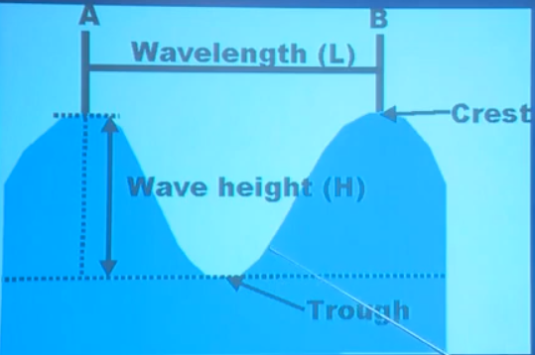

知识点（3）
语法：定语从句嵌套定语从句
- …, and a period (which is the time (which) it takes a wave crest to travel one wave length).

（第三段）

Although an ocean wave gives the impression of a wall of water moving in your direction, in actuality waves move through the water leaving the water about where it was.

语法分析：
Although an ocean wave gives the impression of a wall of water moving in your direction（介词of引出同位语）（although … 让步状语从句）, in actuality（= actually; in fact ） waves move through the water leaving the water about where it was（… 宾语从句）（结果状语）.

知识点（1）Lesson03-24
give (sb.) the impression (that) …: 使（某）人觉得……，给（某）人
的印象是……
- He gives the impression that he really doesn't care.
- The sudden movement of the door made it sway slightly and it gave me the impression that it was about to leap out at me.

be under the impression (that) … 英文解释：to believe that sth. is true when it is not 误以为……
- I'm sorry, I was under the impression that you were the manager.
- Though the crew were at first under the impression that the lost ship had been found, the contents of the sea-chest proved them wrong.

知识点（2）【词汇】
wall n. 英文解释：thing similar to a wall in its appearance or effect （样子或作用、做比喻）似墙之物
- wall of fire / water …
- Firefighters battled the walls of flames.
- The investigators were confronted by a wall of silence.
- The tidal wave formed a terrifying wall of water.
- The Titanic turned just in time, narrowly missing the immense wall of ice which rose over 100 feet out of the water beside her.

知识点（3）Lesson03-34
语法、写作：比喻 （ 喻体 + of + 本体）
- a boy of a girl
- an angel of a wife
- a palace of a house
- a garden of Switzerland
- Jane is a submissive lamb of a girl.
- There is always hope that in its labyrinth of musty, dark, disordered rooms a real rarity will be found amongst the piles of assorted junk that litter the floors.

知识点（4）Lesson03-57、Lesson03-59
in sb.'s direction 朝某人的方向
- Tony glanced in her direction and their eyes met.
- Fortunately for me, as I was wondering what to do next, there appeared on the horizon a man on horseback, riding in my direction.

in the direction of … 朝 …的方向
- Tom went off in the direction of the post office.

in every direction / in all directions 向四方八分
- It is a harmless habit, but it litters up her desk to such an extent that every time she opens it, loose bits of paper fall out in every direction.
- The elephant is not immediately susceptible to such blandishments, however, and usually lashes fiercely with its trunk in all directions.

知识点（5）
in actuality = in reality / actually 事实上
- In actuality, it's much more complex than that.
- The woman he had seen performing on stage was in actuality quite older than she had seemed.

If the water was moving with the wave, the ocean and everything on it would be racing in to the shore with obviously catastrophic results.

语法分析：
If the water was（虚拟语气） moving with the wave（if... 条件状语从句）, the ocean and everything on it would（虚拟语气） be racing in to the shore with obviously catastrophic results（结果状语）.

知识点（1）Lesson03-42复习：虚拟语气
1.语法：虚拟语气if从句的虚拟

1.与现在事实相反
If + S. + did / were, S. + would / should / could / might + do
（主语时单数时，有时也用was，非正式）

- If she was here, she could speak on my behalf.
- If I was rich, I would buy you anything.
- If it was to rain, the ropes would snap.

- 固定约定俗成的场合，用were
- if I were you
- were I you
- as it were
- if it were not for
- were it not for

（第四段）

An ocean wave passing through deep water causes a particle on the surface to move in a roughly circular orbit, drawing the particle first towards the advancing wave, then up into the wave, then forward with it and then -- as the wave leaves the particles behind -- back to its starting point again.

语法分析：
An ocean wave passing through deep water（后置定语） causes a particle on the surface（后置定语） to move in a roughly circular orbit（方式状语）, drawing the particle first towards the advancing wave（状语1）, then up into the wave（状语2）, then forward with it（状语3） and then ― as the wave leaves the particles behind（插入语） ― back to its starting point again（状语4）. （drawing... 伴随状语）

知识点（1）【词汇】
particle n. [C] a very small piece of sth. 微粒
- dust particles
- tiny particles of soil

知识点（2）
知识扩展：海浪运动图
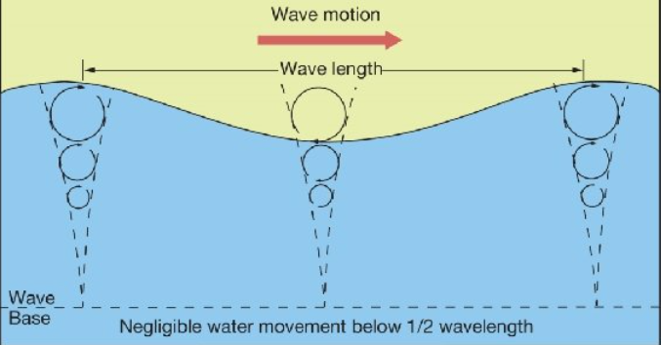


（第五段）

From both maturity to death, a wave is subject to the same laws as any other 'living' thing.

语法分析：
From both maturity to death（介词短语做状语）, a wave is subject to（必须服从或支付） the same laws as any other 'living' thing (is 省略)（比较状语）.

知识点（1）
be subject to … 含义1. if you are subject to a rule, law, penalty etc, you must obey the rule or pay an amount of money 必须服从或支付
- As a diplomat, he is not subject to local laws.
- Violators are subject to a $100 fine.
- Cars are subject to a high domestic tax.

be subject to … 含义2. often having, suffering or undergoing sth 常有、常患
或常遭某事物
- Are you subject to colds?
- Trains are subject to delays after the heavy snowfalls.
- The timetable is subject to alteration.

be subject to … 含义3. depending on sth. as a condition 需要某事物（为先决条件），取决于……
- The plan is subject to the director's approval.
- Goods will be sent out within 14 days, subject to availability.
- So let us begin anew—remembering on both sides that civility is not a sign of weakness, and sincerity is always subject to proof. Let us never negotiate out of fear, but let us never fear to negotiate. —— John F. Kennedy

知识点（2）
as conj. 像
- From both maturity to death, a wave is subject to the same laws as any other 'living' thing (is省略).
- From both maturity to death, a wave is subject to the same laws as (is) any other 'living' thing. （倒装）

For a time it assumes a miraculous individuality that, in the end, is reabsorbed into the great ocean of life.

语法分析：
For a time（时间状语，一时） it assumes a miraculous individuality that, in the end（插入语）, is reabsorbed into the great ocean of life（that ...定语从句）.

知识点（1）
for a time 英文解释：temporarily, for a certain period 暂时，一时，一度
- This method was used for a time, but it is no use now．
- He was for a time a professor at Cambridge．

知识点（2）【词汇】
assume v. (fml.) 英文解释：to start to have a particular quality or appearance 开始拥有（某种特征或外表）
= take on
- These relationships assume great importance in times of crisis.
- In the story the god assumes the form of an eagle.

知识点（3）【词汇】
individuality n. [U] 英文解释：the qualities that make sb. or sth. different from other things or people 个性，个人特征
- We like our staff to show their individuality rather than wear a uniform.
- The plot is credible but the characters lack individuality.

知识点（4）【词汇】
reabsorb v. 英文解释：to absorb again 再次吸收，使再次融入
reabsorb … into … 再次融入…
- The economy cannot reabsorb all of the refugees into the workforce.

（第六段）

The undulating waves of the open sea are generated by three natural causes: wind, earth movements or tremors, and the gravitational pull of the moon and the sun.

语法分析：
The undulating waves of the open sea are generated by three natural causes: wind（同位语1）, earth movements or tremors（同位语2）, and the gravitational pull of the moon and the sun（同位语3）. （by ... 方式状语）

知识点（1）【词汇】
undulate v. (fml.) 英文解释：to move or be shaped like waves that are rising and falling 波动，呈波浪状起伏
- undulating hills
- a field of wheat undulating in the breeze

知识点（2）【词汇】
tremor n. 含义1. a small earthquake in which the ground shakes slightly 轻微地震
- an earth tremor

tremor n. 含义2. a slight shaking movement in your body that you cannot control, especially because you are ill, weak, or upset 颤抖
- There was a slight tremor in his voice.
- She felt a tremor of fear run through her.

知识点（3）【词汇】
gravitational adj. 英文解释：related to or resulting from the force of gravity 重力的
- gravitational field 重力场
- gravitational pull 引力

Once waves have been generated, gravity is the force that drives them in a continual attempt to restore the ocean surface to a flat plain.

语法分析：
Once waves have been generated（时间状语从句）, gravity is the force that drives them in a continual attempt（状语） to restore the ocean surface to a flat plain（that ...定语从句）.

知识点（1）
restore sth. to sth. 把…恢复到…
- The government promises to restore the economy to full strength.
- She was hoping that the Mediterranean climate would restore her to full health.

